Chain of Command
(Knowledge sheet) as of 24 Sep 25
President of the United States Honorable Donald Trump
Vice President of the United States Honorable JD Vance
Secretary of War Honorable Pete Hegseth
Secretary of the Air Force Honorable Dr. Troy Meink
Chairman of the Joint Chiefs of Staff General Daniel Caine
Senior Enlisted Advisor to the Chairman of the Joint Chief
Of Staff (SEAC) Fleet Master Chief David Isom
Air Force Chief of Staff Gen David Allvin
Chief Master Sergeant of the Air Force CMSgt David A. Flosi
Commander of Air Education and Training Command (AETC) Lt Gen Brian Robinson
Commander of Air University Lt Gen Andrea Tullos
Commander of Air Force Officer Accessions
And Training School (Holm Center) Brig Gen Joseph Sheffield
Director of Air Force JROTC Col Matthew Tipton
Senior Aerospace Science Instructor Major Thomas Kleczkowski
Aerospace Science Instructor MSgt Carlos Recoder

OTHER NAMES/TITLES TO KNOW NOT IN THE DIRECT CHAIN OF COMMAND
U.S. Attorney General Honorable Pam Bondi
Speaker of the House of Representatives Honorable Michael Johnson
Secretary of State Honorable Marco Rubio
Governor of Texas Honorable Greg Abbott
Mayor of San Antonio Honorable Gina Ortiz Jones
U.S. Senators of Texas Honorable Ted Cruz
Honorable John Coryn
Sonia Sotomayor Principal Mrs. Ada Bohlken

Air Force Core Values

- Integrity First 2. Service Before Self 3. Excellence in all we do

Sonia Maria Sotomayor ( born June 25, 1954) is an associate justice of the Supreme Court of the United States. She was nominated by President Barack Obama on May 26, 2009, and has served since August 8, 2009. She is the third woman, first woman of color, the first Hispanic, and first Latina to serve on the Supreme Court.

Air Force Instruction (AFI) 36-2903: Dress and Appearance of Air Force Personnel is the directive that governs dress and appearances of Air Force Personnel

Department of the Air Force Pamphlet 34-1203: Drill and Ceremonies, Dated 13 Sep 22,
page 9, Chapter 1, paragraph 1.1.2 Units or organizations required to drill under arms will use the procedures in Army Training Circular 3-21.5, Drill and Ceremonies

USAF Active Duty Ranks
Airman
Title Abbreviation Pay Grade

NO STRIPES Airman Basic AB E – 1

Airman Amn E - 2


Airman First Class A1C E – 3

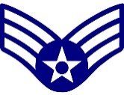
Senior Airman SrA E - 4

Noncommissioned Officer (NCO)

Staff Sergeant SSgt E – 5


Technical Sergeant TSgt E – 6

Senior Noncommissioned Officers (SNCO)

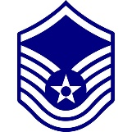
Master Sergeant MSgt E – 7
Master Sergeant, First Sergeant position with diamond


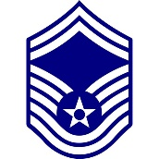
Senior Master Sergeant SMSgt E – 8
Senior Master Sergeant, First Sergeant position with diamond


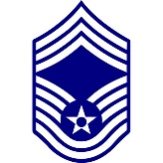
Chief Master Sergeant CMSgt E – 9
Chief Master Sergeant, First Sergeant position with diamond

Title Abbreviation Pay Grade
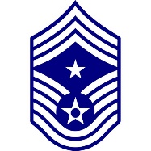
Command Chief Master Sergeant CCMSgt E - 9

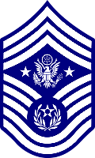

Chief Master Sergeant of the Air Force CMSAF E - 9

OFFICER RANK
Company Grade Officers (CGO)

Title Abbreviation Pay Grade


Second Lieutenant 2nd Lt O – 1


First Lieutenant 1st Lt O – 2


Captain Capt O - 3

Field Grade Officers (FGO)


Major Maj O – 4


Lieutenant Colonel Lt Col O – 5


Colonel Col O - 6

General (Flag) Officers

Title Abbreviation Pay Grade


Brigadier General Brig Gen O - 7



Major General Maj Gen O - 8


Lieutenant General Lt Gen O - 9

General Gen O - 10



General of the Air Force O - 10
(Reserved for wartime only)

